Hoi An Lantern Festival

Having a strong tradition of Buddhism, Vietnamese always believe that the full moon is a significant time in the lunar month. In Vietnam, these traditions have morphed into many festivals including the popular Hoi An Lantern Festival which is held to celebrate the full moon. It is said that the full moon is one of the most sacred times in the Buddhist calendar because Buddha was not only born on a full moon but attained enlightenment on a full moon. Nowadays, people all over Asia view the full moon is a time to meditate, observe rituals, reflect on life, and worship their ancestors. This is done in many ways from offerings made at family shrines to the burning of incense and the lighting of candles.

The Origin of Hoi An Lantern Festival

During the 16th and 17th centuries, Hoi An was an important port of the country which bustled with merchants from around the world. At that time, many Japanese also came here and brought with them variously shaped lanterns that they would hang in front of their homes. Since then, the locals began to imitate this in similar hopes of bringing good luck to their households which was contributed to the development of the traditional lanterns. The diverse culture of the ancient town has been widely associated with lanterns. Understood that thing, the local authorities decided to combine lanterns with the monthly full moon celebrations in 1998. Since then, both Vietnamese and international tourists have flocked to Hoi An each month to participate in the celebrations.

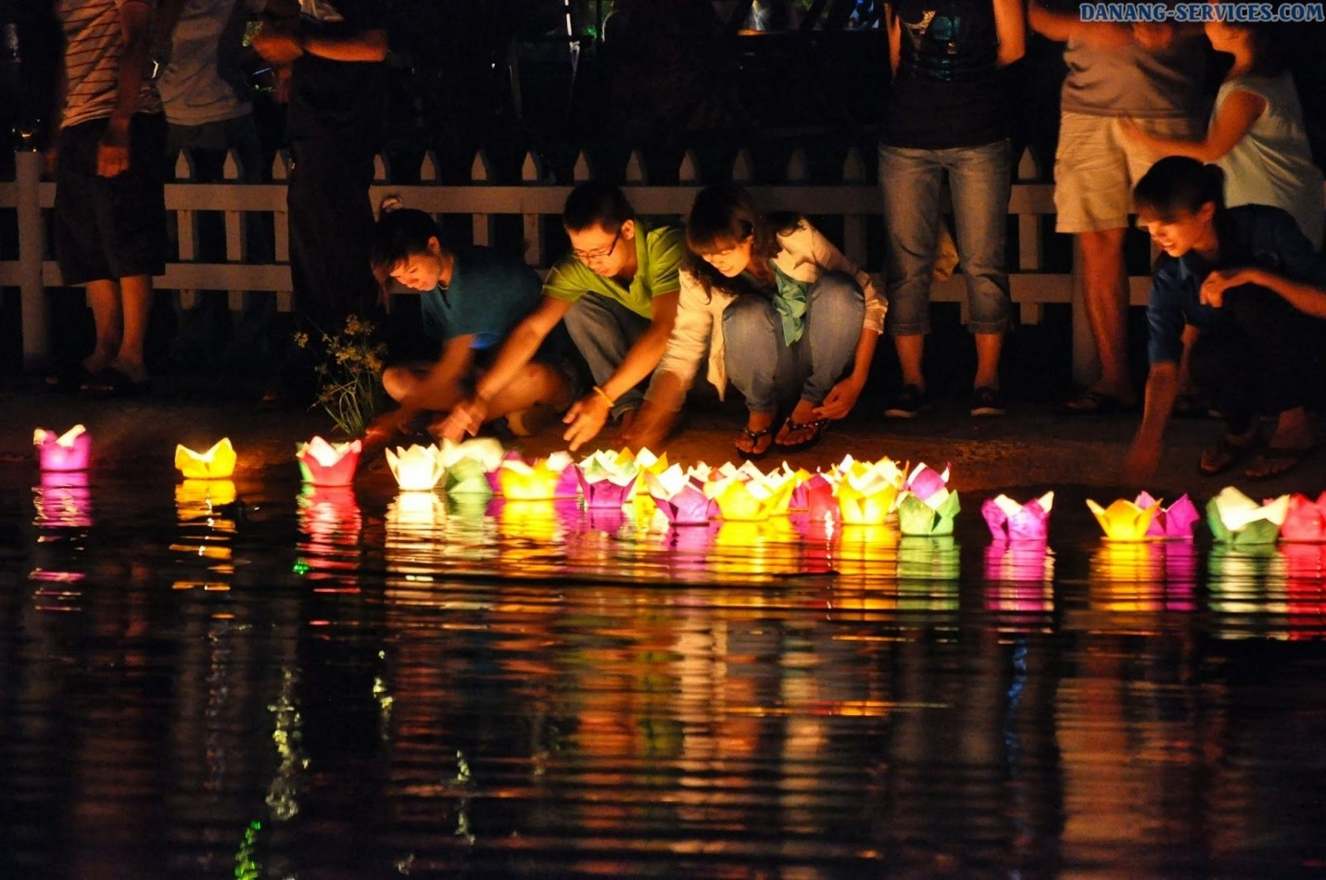

**Best Things to Do & See in Hoi An Lantern Festival**

As the name suggests, this festival is full of colorful lanterns that are lit with candles and placed on the Hoai River with a wish for happiness, luck, and love. On the festival day, all fluorescent lights are turned off at 8 pm so that the floating lanterns are all that illuminate Hoi An, creating a magical glow. All vehicles and bicycles are banned in the town, so tourists can wander around and soak up the atmosphere without fear of walking into the path of a motorist. Attending the celebration, you can enjoy many impressive performances that are held along the river with music and poetry readings. Strolling around the town, you will see locals playing board games outside their homes while others gather for Bai Choi – a musical version of bingo.

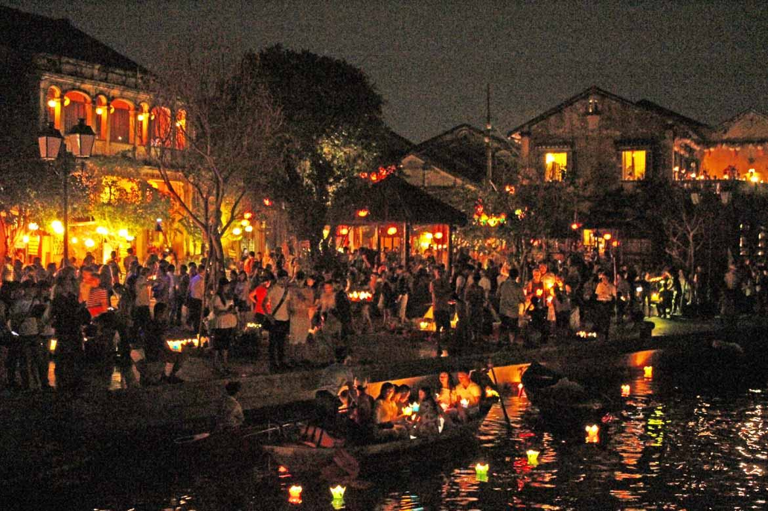

**Tasting Yummy Street Foods**

Visiting Hoi An ancient town, you can sample a ton of local dishes such as cao lau (rice noodles with pork and veggies), chicken rice, or banh bao (steamed rice dumplings with pork and mushrooms). Soak into the market of the town, you will be excited by a lot of tasty dessert-like banh dap, banh beo, banh bot loc, che xoa xoa, etc. Do not forget to pick up some Vietnam souvenirs for your family member and friends.

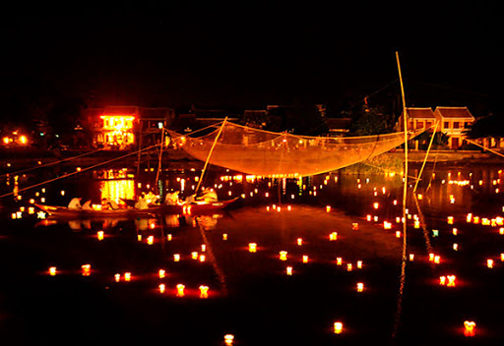

**Dates of Hoi An Lantern Festival**

The Hoi An Lantern Festival takes place on the 14th day of each lunar month.